Question : 1
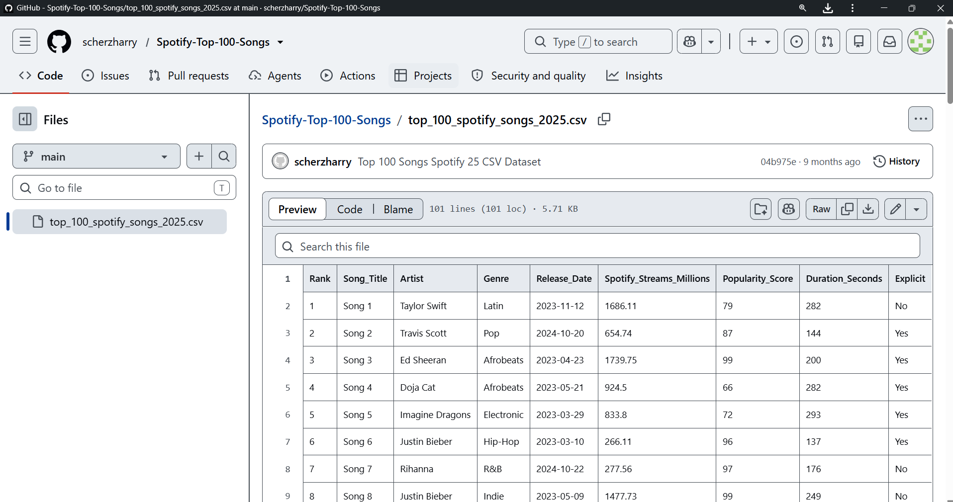
Install the pandas-profiling library and generate a profile report for the 'Spotify Top 100 Songs' dataset (CSV available on Kaggle); open the HTML report and note any missing values or data type issues :
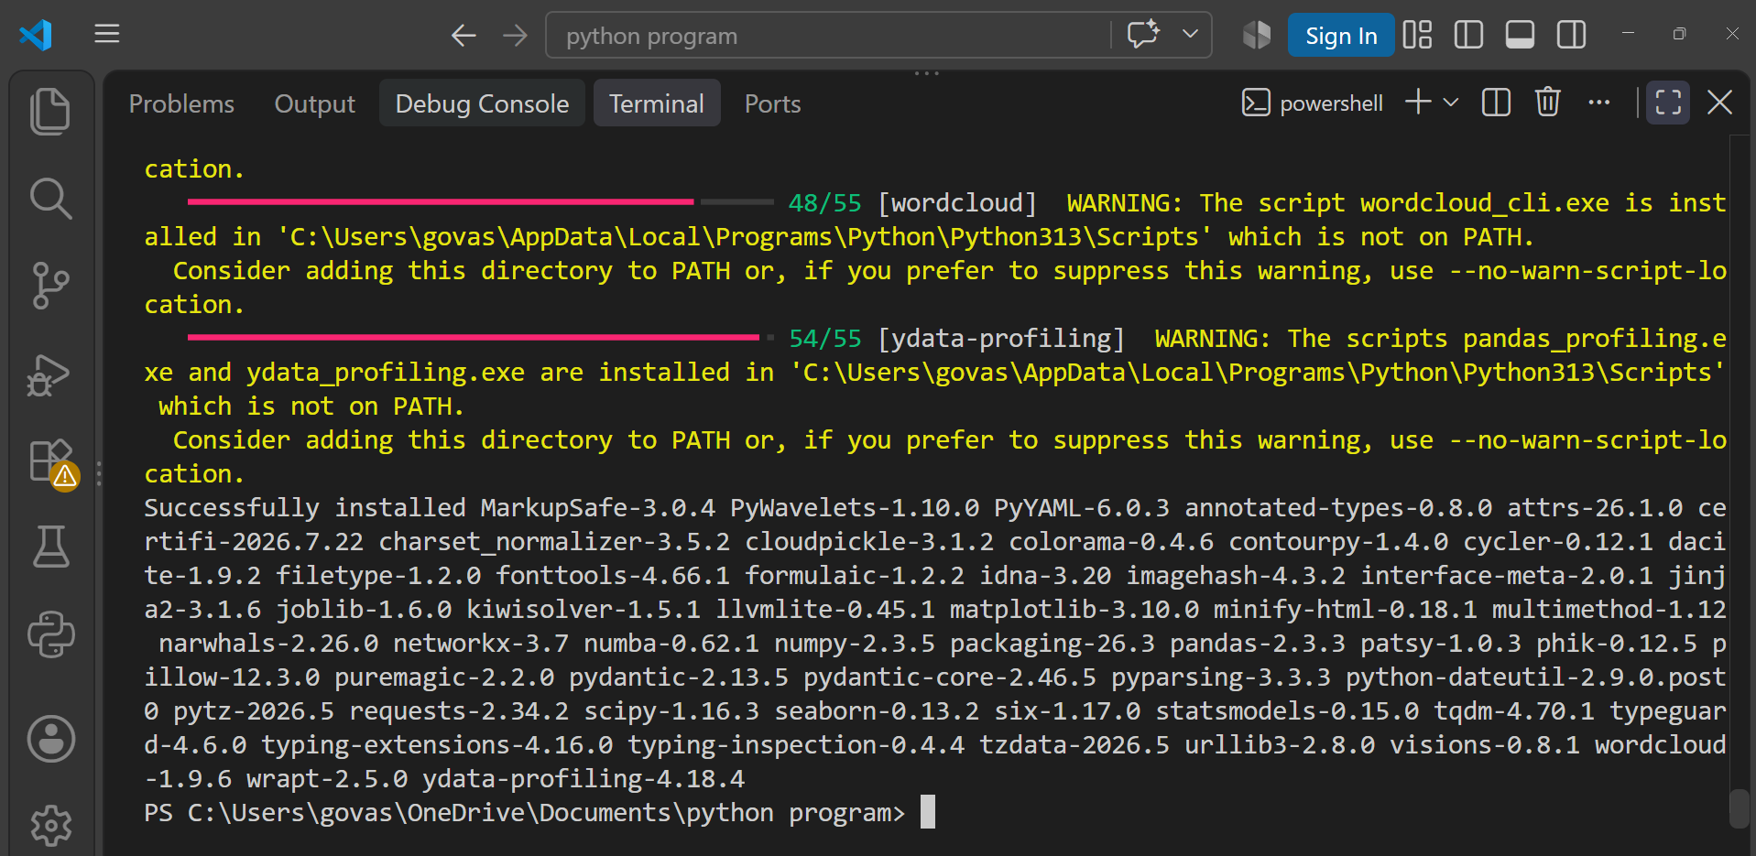
py -3.13 -m pip install ydata-profiling
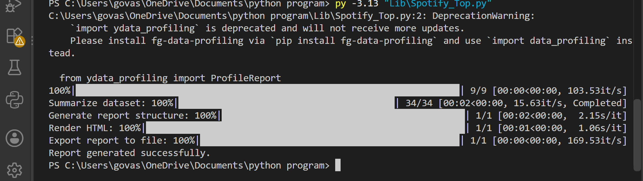
Missing Values:
- No missing values were found in the dataset (0 missing cells).
Data Type / Data Quality Issues:
- The Rank column contains unique values and is uniformly distributed.
- Song_Title and Spotify_Streams_Millions also contain unique values, which were flagged by the profiling report.

Question : 2
Use Sweetviz to create a comparison report between two CSV files: one containing Zomato restaurant data for Mumbai and another for Delhi. Briefly describe one key difference you spot in the visual report.<br><br><em><strong>Hint:</strong> Use analyze() for single file and compare() for two datasets : </em>

py -3.13 -m pip install sweetviz

import pandas as pd
df = pd.read_csv("Lib/zomato.csv", encoding="latin1")
mumbai = df[df["City"] == "Mumbai"]
delhi = df[df["City"] == "New Delhi"]
mumbai.to_csv("Lib/zomato_mumbai.csv", index=False)
delhi.to_csv("Lib/zomato_delhi.csv", index=False)
print("Mumbai rows:", len(mumbai))
print("Delhi rows:", len(delhi))
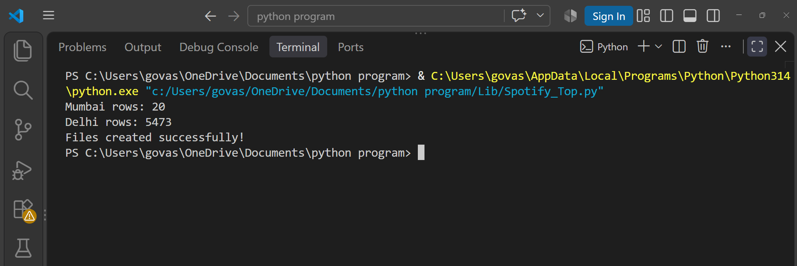
print("Files created successfully!")

